
SCHIRMER STRIPS
Indications
- Used for measurement of tear production
Specifications
- Each strip has a printed mm scale so that they can be easily read
- Available as sterile strips in individual pouches
- Innovative peel open packing with a transparent film on one side
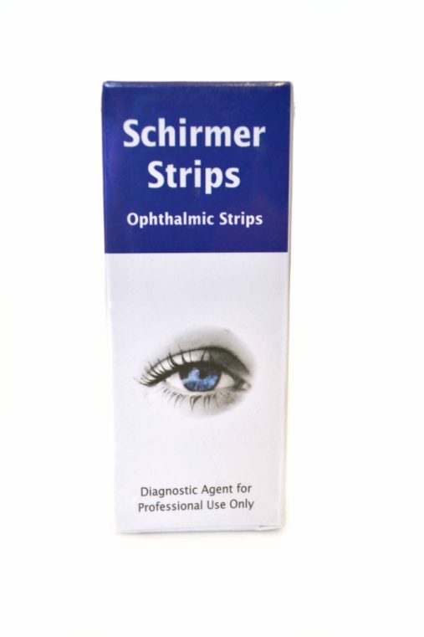
Central India Exports / Indian Ophthalmics,
6-7, Shrivardhan Complex, Ramdaspeth,
Wardha Road,Nagpur-440012,Maharashtra,India
Tel/Fax::+91-712-2429168 / 2453983, Mo::+91-9822200622
Email:: cie@cieindia.com, vaidsandeep100@gmail.com, centralindiaexport1@gmail.com
Website::www.cieindia.com,
OPHTHALMIC WEBSITE-- www.centralindiaexport.com
Skype:: vaidsandeep100

